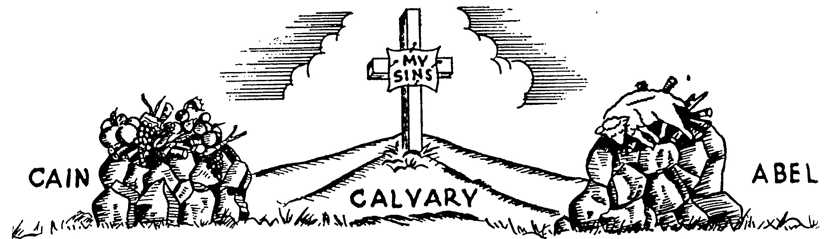

THERE IS NO FORGIVENESS UNLESS BLOOD IS SHED
Study this lesson carefully before answering the questions.

WHAT IS SALVATION?
Salvation is not a religion. Many people are very religious but they have never been saved. Being good and going to church every Sunday is not salvation. Salvation is believing and receiving Christ as your own Savior. When you do this you receive the Lord Jesus into your life--you are Born Again. This makes you a child of God. When you were born into your parents’ family, you received natural life. When you are born into God’s family, you receive Spiritual life. This is the life of the Lord Jesus within you. Jesus says in Revelation 3:20, “Behold, I stand at the door and knock: if any man (boy or girl) hear my voice, and open the door I will come in.”

WHY IS SALVATION NECESSARY?
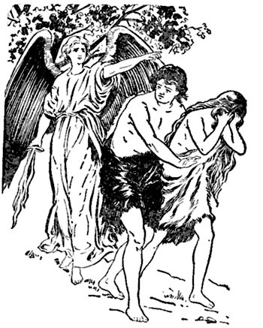
Study Genesis Chapter 3. We read in Romans 5:12 that because Adam sinned, every one of us has sin in us. God is holy and will not let sin be where He is. He hates sin and will punish those who have sinned. God loved Adam and Eve, but He had to be sure that punishment was given because of their sin. God took animals that did not deserve to die and killed them instead of Adam and Eve. Then He took the skins of the animals and made coats for the two sinners. God caused the animals to die to show how much He hates sin. He will not forgive sins unless blood is shed and a life is given as punishment for the sinner. This is the first picture that God gives in the Bible of how Jesus died for us. Only the blood of Jesus can wash away our sin. We need salvation because all have sinned. Since God hates sin, He will punish all those whose sins are not forgiven. We must have our sins taken away if we want to live in heaven where God and the Lord Jesus are, and where no sin can enter. Study the Gospel of John 3:36.

CAIN AND ABEL
Read Genesis 4: 1-16. No doubt Adam and Eve told their children all about their lovely home in the Garden of Eden and why God had driven them out of it. They must also have told how God had slain the animals instead of them, and gave them the skins for coats. Cain and Abel probably helped their father build altars like those in the picture above. They saw their father kill the animal, shed its blood and offer it to God by burning it on the altar.
-OVER-

THE TWO OFFERINGS
CAIN’S OFFERING--When Cain and Abel were old enough, they brought their own offerings to the Lord. Cain did not listen to what God had said about the shedding of blood. He was a farmer and had many fine fruits and vegetables. He brought the very best of these as an offering to the Lord, thinking that God would forgive his sins. Cain’s sacrifice is a picture of those today who think they can earn forgiveness of sin by doing their best, giving to the poor, going to church, or being very kind. We will want to do these things after we are saved. But God will not accept these things for the forgiveness of sins because there is no blood. We must do things God’s way, and obey Him. You remember the song which goes like this: “What can wash away my sin? Nothing but the blood of Jesus.” Cain proved how sinful he was, for he killed his brother. Cain was the first murderer.
ABEL’S OFFERING--Abel was a shepherd who loved his sheep. Yet, he knew he had to obey God if he wanted his sins forgiven. He killed one of his lovely lambs and put it in his place on the altar. This is what God wanted, so God forgave Abel’s sins and gave him peace in his heart. This is a picture of all those who will take Jesus as their Savior. Jesus died in their place. They will have their sins forgiven and have peace in their hearts. Both brothers were sinners because they were children of sinful Adam and Eve. Yet only one found forgiveness, Abel, because the shed blood of the lamb covered his sins.

A PERFECT PICTURE
The innocent lamb slain and offered as a sacrifice in the place of the sinner is a perfect picture of the Lord Jesus, the spotless Lamb of God, who died on Calvary in our place. All through the Old Testament times, God was explaining the way of salvation. The people were commanded to bring blood sacrifices, for “without shedding of blood is no remission” (Hebrews 9:22) which means without the shedding of blood sins will not be forgiven. Just as the lamb was slain and laid on the altar, so Jesus died on the cross. The lamb had no sin for which it had to die. Even so Jesus had no sin for which He had to die. He was perfect and sinless, yet, it was for our sins that He suffered. It was your sins and mine that made Him die on the cross.

THE BEE STUNG MOTHER
A mother had tried to explain to her little boy what Jesus had done for him, but he did not seem to understand. One day he began throwing stones at a bee’s nest. A very angry bee came buzzing round and round his head. The boy tried several times to drive it away, but the bee came closer and closer. The mother saw her son in danger and ran to him. She threw her apron over him, and put her arms around him, but as she did so, the bee stung her deeply. As she felt the sharp pain in her own arm, she said, “You may come out now, the bee has stung mother. It cannot hurt you anymore, for it has only one sting.” The boy looked at the fast swelling arm and while he did so, his mother explained that this was like what Jesus had done--He died on the cross and received the sting of sin for him just as she had taken the bee’s sting in his place. Then the little boy understood and tears of joy ran down his cheeks.

ARE YOU?
Some Christians wear a button with this question on it, “ARE YOU?” It causes others to ask, “Are you what?” This gives the person wearing the button a chance to ask, “Are you saved?” Right here we would like to ask you the same question. “Are you saved?” Have you seen yourself as a sinner and believed that the Lord Jesus took your sins and hung upon the cross for you? If you have not been born again, will you get down on your knees and tell Jesus you believe He died for you, and that you want Him to come into your life right now? Many plan to be saved sometime, but God says, “Behold, now is the accepted time; behold, now is the day of salvation.” Tomorrow may be too late! If you are saved, why not bow your head and thank your Heavenly Father again that Jesus saved you and lives in you?
Name |  |  |  |  |  | Grade |  |  |  | Date:
Mailing Address |  |  |  |  |  |  |  |  |  | Phone#:
City |  |  |  | State |  |  | Zip |  |  | School

Complete the following in your own words:
Salvation is ___________________________________________________________
_____________________________________________________________________
Salvation is necessary because ____________________________________________
______________________________________________________________________

Circle the correct sentence ending
1. Cain’s offering is a picture of
A. Those who think their own good works can bring forgiveness.
B. Those who wish to obey the Lord.
C. Those who want people to help them.
2. Abel’s offering is a picture of those
A. Who are depending on other people.
B. Who find forgiveness in Jesus as their Savior.
C. Who want their own way.
3. The Bible verse which includes this, “Without the shedding of blood there is no remission of sin,” is found in:
A. Hebrews 9:22
B. 1 John 1:7
C. John 3:36
-OVER-

Fill in the blank with the correct word from the Word List:
4. God punished ___________________ by death as a substitute for the

Word List:
Jesus Animals
John Leaves
Cain Abel
Fruits and vegetables

sin of Adam and Eve.
5. Cain brought ___________________ as his offering to the Lord.
6. The slaying of a lamb as a sacrifice in place of the sinner is a perfect
picture of ________________________________.
7. _________________________ was the son of Adam and Eve who found
forgiveness because the shed blood of the lamb covered his sin.

Fill in the missing words from 1 Peter 1:18-19 (KJV) using the Word List:

Word List:
Lamb Precious
John Gold
Christ Blood
Silver
8. Forasmuch as ye know that ye were not redeemed with corruptible things as
__________________ and __________________, but with the
________________________ _____________________ of
____________________, as of a __________________________ without
blemish and without spot.

-OVER-

Write out Isaiah 53:6

__________________________________________________________________

__________________________________________________________________

__________________________________________________________________

__________________________________________________________________

__________________________________________________________________

How does the story of the Mother being stung by a bee show us what Christ did for us?
9. The Mother took the ________________ of the bee for her son; and Jesus took the
___________________ of ___________________ for us.

Return Answers to: Camp Grace 145 Grace Drive Fairmont, NC 28340

